**Technical Documentation – Release_ONLINE_BATCH_Forms_Reports_to_MUAT**

1. Workflow – Releases FAR Environments from a TEST environment to MUAT/MAINT.

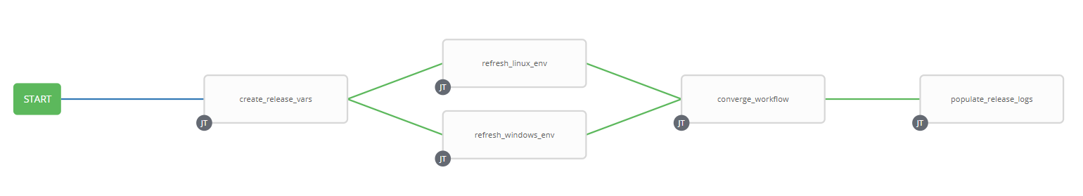

1. Survey – User Supplied Variables

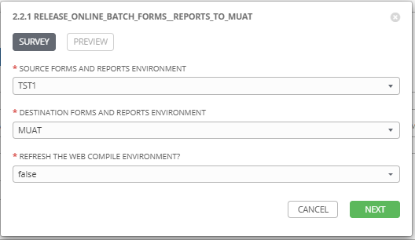

|  |  |  |  |
| --- | --- | --- | --- |
| **Survey Extra Variables** | **Prompt** | **Type** | **Description and Usage** |
| SOURCE | Source Forms and Reports Environment | Multiple Choice Single Pick | Environment to copy FAR Artifacts FROM (TST1, TST2, TST3). |
| DESTINATION | Destination Forms and Reports Environment | Multiple Choice Single Pick | Environment to copy FAR Artifacts TO (MUAT is all that is allowed). |
| REFRESH_WEB | Refresh the Web COMPILE Environments | Multiple Choice Single Pick | true or false (default is false). If this is set to true the WEB Compile environment will be released. |

1. Jobs Used by the workflow - http://owl.penc.local:18080/svn/deploy_automation/trunk/Ansible_PlayBooks/FAR

| **Job Template** | **Ansible Playbook** | **Credentials / host** | **Project** | **Description and Usage** |
| --- | --- | --- | --- | --- |
| create_release_env_vars | create_release_env_vars.yml | None – runs on localhost as awx linux user | FAR Deployments | Destination_Batch_Compile_Directory: \\cronrepmaint\Reports$\defs\muat  Destination_Online_Compile_Directory: /export_home/codemove/compile/ipas12c/muat  Destination_Online_Runtime_Directory: /opt/ipas_app_test/muat  Destination_WEB_Compile_Directory: /export_home/codemove/compile/ipas12c/webm  Source_Batch_Compile_Directory: \\cronreptest1\Reports$\defs\tst3  Source_Online_Compile_Directory: /export_home/codemove/compile/ipas12c/tst3  Source_Online_Runtime_Directory: /opt/ipas_app_test/tst3  Source_WEB_Compile_Directory: /export_home/codemove/compile/ipas12c/webt  batch_far_server: cronreptest1  date_time: '20200828_1043'  far_server: taras1bcp  open_chmod: false  stage_server: daulis1bcp  tower_hostname: pdeploy1bcp.penc.local |
| refresh_linux_env | refresh_linux_env.yml | Codemove on {{far_server}} typically taras1bcp | FAR Deployments | Backs up the {{Destination_Online_Compile_Directory}}, {{Destination_Online_Runtime_Directory}} and {{Destination_WEB_Compile_Directory}} Directories and then copies the {{Source_Online_Compile_Directory}}, {{Source_Online_Runtime_Directory}} and {{Source_WEB_Compile_Directory}} (When {{REFRESH_WEB}} is true) to the corresponding Destination Directories.  If the Destination is a Development environment the file and directory attributes are opened up to chmod g+rwx to allow developers to update them. |
| refresh_windows_env | refresh_windows_env.yml | Penc\ora_cronreptest on {{batch_far_server}} typically cronreptest1 | FAR Deployments | Backs up the {{Destination_Batch_Compile_Directory}} and then copies the {{Source_Batch_Compile_Directory}} to {{Destination_Batch_Compile_Directory}}. |
| converge_workflow | converge_workflow.yml | None – runs on localhost as awx linux user | FAR Deployments | A simple convergence job to ensure both refresh_linux_env and refresh_windows_env both complete before proceeding. In earlier versions of Ansible Tower if one converging job completed the next step in the workflow always executed, which is not what we want here. |
| populate_release_logs | populate_release_logs.yml | Codemove on {{stage_server}} typically daulis1bcp | FAR Deployments | If both the refresh_windows_env and refresh_linux_env complete successfully create and populate the /codemove_common/dp_automation/releases/{{DESTINATION}}_{{Release_Date}}/{{DESTINATION}}_Release_log.html file. |